ReactJS Hands-on Lab
Building a Student Score Calculator using React Function Components

Objectives
- Explain React components
- Identify the differences between components and JavaScript functions
- Identify the types of components
- Explain class component
- Explain function component
- Define component constructor
- Define render() function
In this hands-on lab, you will learn how to:
- Create a function component
- Apply style to components
- Render a component

Objectives — Explained

1. Explain React components
Components are the building blocks of a React application. A component is an independent, reusable piece of UI that accepts inputs, called props, and returns a React element (JSX) describing what should appear on the screen. A React application is essentially a tree of components nested inside one another, each responsible for rendering its own part of the UI.

2. Differences between components and JavaScript functions
A React function component is, technically, a JavaScript function, but it behaves differently from an ordinary function in several ways:
- A component must return JSX (React elements) describing UI, whereas a normal function can return any value or nothing at all.
- A component receives a single special object called props, while a regular function can accept any arbitrary parameters.
- React controls when a component function is invoked (during rendering, and again whenever state or props change); a normal function is called explicitly by the programmer wherever needed.
- Components can hold and manage state and side effects (using Hooks such as useState/useEffect in function components, or this.state and lifecycle methods in class components); plain functions have no such concept.

3. Types of components
React supports two types of components:
- Class components — ES6 classes that extend React.Component, define a render() method that returns JSX, and can hold local state via this.state.
- Function components — plain JavaScript functions that accept props and return JSX directly. With Hooks, they can also manage state and side effects, and are the recommended approach in modern React.

4. Explain class component
A class component is defined using an ES6 class that extends React.Component. It must implement a render() method that returns the JSX to be displayed. Class components can define a constructor to initialize state and bind event-handler methods, access incoming data through this.props, and use lifecycle methods (such as componentDidMount) to run code at specific points in the component's life.
class Welcome extends React.Component {
render() {
return <h1>Hello, {this.props.name}</h1>;
}
}

5. Explain function component
A function component is a simpler way of writing a component using a plain JavaScript function instead of a class. It accepts props as its argument and returns JSX directly, without needing a separate render() method, constructor, or the 'this' keyword. Using Hooks (useState, useEffect, etc.), function components can also manage local state and side effects, making them the preferred style in modern React development.
function Welcome(props) {
return <h1>Hello, {props.name}</h1>;
}

6. Define component constructor
The constructor is a special method of a class component that runs automatically when the component is created (instantiated). It is used to initialize the component's local state (this.state) and to bind event-handler methods to the component instance. Inside a constructor, super(props) must be called first so that this.props is set up correctly before any other code runs.
constructor(props) {
super(props);
this.state = { count: 0 };
}

7. Define render() function
The render() method is a required method in every class component. It examines this.props and this.state and returns the JSX (React elements) describing what should appear on the screen. React calls render() automatically whenever the component is first mounted and again whenever its state or props change, so the UI stays in sync with the underlying data. Function components do not define a separate render() method — the body of the function itself serves the same purpose, returning the JSX to display.

Prerequisites
The following is required to complete this hands-on lab:
- Node.js
- NPM
- Visual Studio Code

Notes
Estimated time to complete this lab: 30 minutes.
Create a React app for a Student Management Portal named "scorecalculatorapp" and create a function component named "CalculateScore" which will accept Name, School, Total, and Subjects in order to calculate the average score of a student and display the same.

Lab Steps

1. Create a React project named "scorecalculatorapp"
Type the following command in the terminal of Visual Studio Code:
npx create-react-app scorecalculatorapp

2. Create the Components folder
Create a new folder under the src folder with the name "Components". Add a new file named "CalculateScore.js" inside it.

3. Add code to CalculateScore.js
Type the following code in CalculateScore.js:
import React from 'react';
import '../Stylesheets/mystyle.css';

function CalculateScore(props) {
const average = props.total / props.subjects;

return (
<div className="score-card">
<h1 className="title">Student Score Calculator</h1>
<p className="info">Name : {props.name}</p>
<p className="info">School : {props.school}</p>
<p className="info">Total Marks : {props.total}</p>
<p className="info">Subjects : {props.subjects}</p>
<p className="info">Average Score : {average}</p>
</div>
);
}

export default CalculateScore;

4. Add styles to the component
Create a folder named "Stylesheets" and add a file named "mystyle.css" in order to add some styles to the component:
.score-card {
width: 500px;
margin: 100px auto;
padding: 40px;
background-color: #ffffff;
border-radius: 10px;
box-shadow: 0px 4px 10px rgba(0, 0, 0, 0.2);
text-align: center;
}

.title {
color: blue;
font-size: 32px;
}

.info {
color: green;
font-size: 20px;
font-weight: bold;
}

5. Edit App.js to invoke the CalculateScore component
Edit the App.js file to invoke the CalculateScore functional component as follows:
import React from 'react';
import CalculateScore from './Components/CalculateScore';

function App() {
return (
<div className="App">
<CalculateScore
name="Harshini"
school="Vignan University"
total={480}
subjects={6}
/>
</div>
);
}

export default App;

6. Run the application
In Command Prompt, navigate into scorecalculatorapp and execute the code by typing the following command:
cd scorecalculatorapp
npm start

7. View the output in the browser
Open a browser and type "localhost:3000" in the address bar. The Student Score Calculator is displayed as shown below:
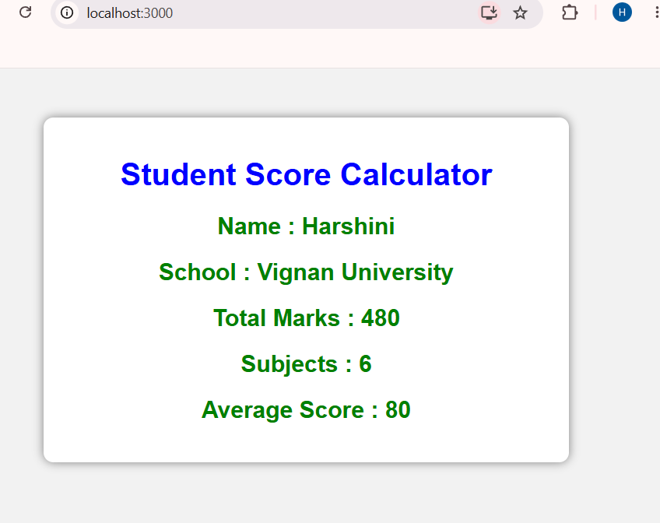
Output: Student Score Calculator running at localhost:3000

Summary
In this lab, a React function component named CalculateScore was created to accept a student's Name, School, Total marks, and number of Subjects as props, compute the average score, and render the result. A separate stylesheet was used to style the component, which was then rendered inside App.js and verified in the browser at localhost:3000.

